**WEATHER API TECHNICAL DOCUMENT**

**Objective:**

Our Objective is to get the weather-related report from the web using the website <https://stormglass.io/dashboards>. It will return a JSON file having the weather details.

**API Outputs:**

The website returns a file of JSON type file consisting of following parameters like: DeviceId, Air Temperature, Cloud Cover, Air Pressure, Wind direction, Humidity, Visibility, Wind Speed, Event Date and Time.

**How to Get the data:**

Steps:

1. Open Desktop

1. Right Click on this Folder Weather API

1. Extract the Weather_API.zip on your PC it consist of all the source code and Weather.XML which is required.
2. After opening Weather.XML, update the dependencies “MASTERRECEIVEURL” in the Weather.XML to get the value click sign in and then sign in.

1. After sign in we will get a “API KEY” from the website stormglass.io

1. Copy that key and replace that with “MASTERRECEIVEURL” of the XML here shown with arrow between

“MASTERRECEIVEURL”> REPLACE HERE </item>

1. Now Open the Code File “VaaaNWeatherEventv2.2.py” in notepad++ from the folder Weather API:

**Code Explanation:**

1. Graphical user interface, text, application, email

   Description automatically generatedImporting Libraries
2. Parsing Weather.xml data in config_data variable.

1. This is used to get first hour and the last hour of the day
2. 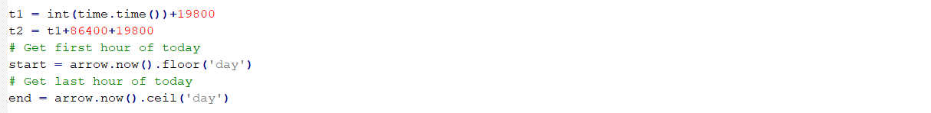
3. The above Code return Location Id, Device Type, Device type Name, Direction etc.

1. Function to Process temperature

1. Function to Send the event on API

1. It Create Folder and sends create a JSON file for each hour.

1. For example Weather2 having data of 10 AM and Weather3 has data for 11 AM and so on .

1. If hour is divisible of 2 then it checks minutes, if minutes is less than 9 then only it run Send Event Function else it will pass and do not call Send Event.